Forward Kinematics Screen Shots

A random joint configuration is generated. The rigid transform g is computed according to the forward map. These images show a frame placed g relative to the base frame, and then ur5 set to the original joints (and how it lines up with the placed frame).

**Transform 1**

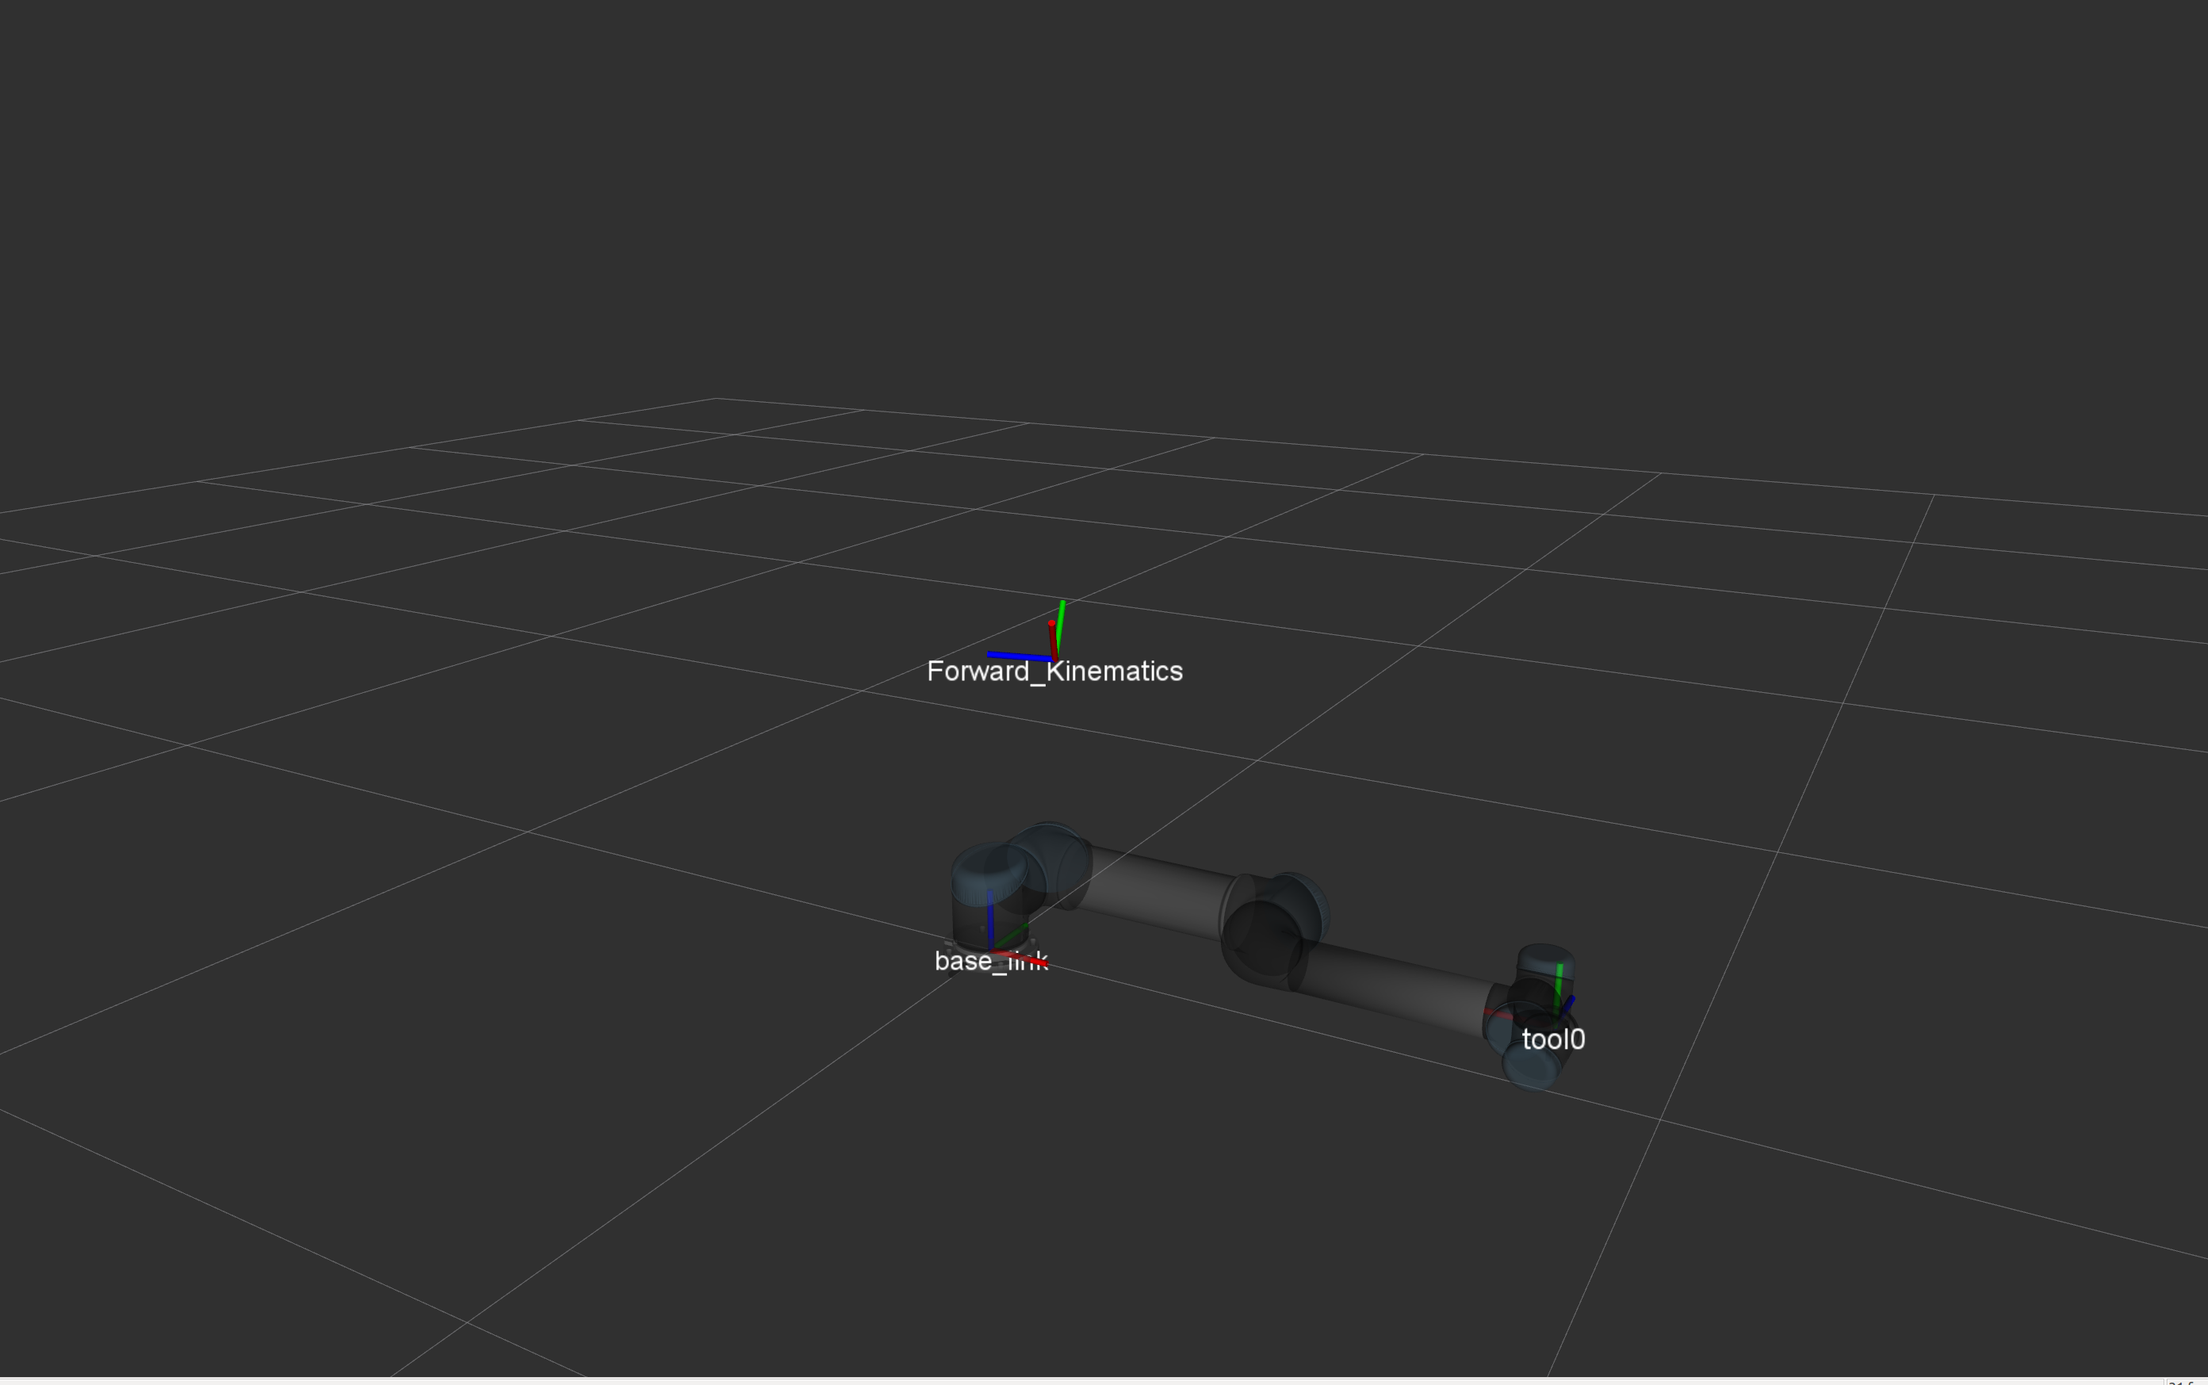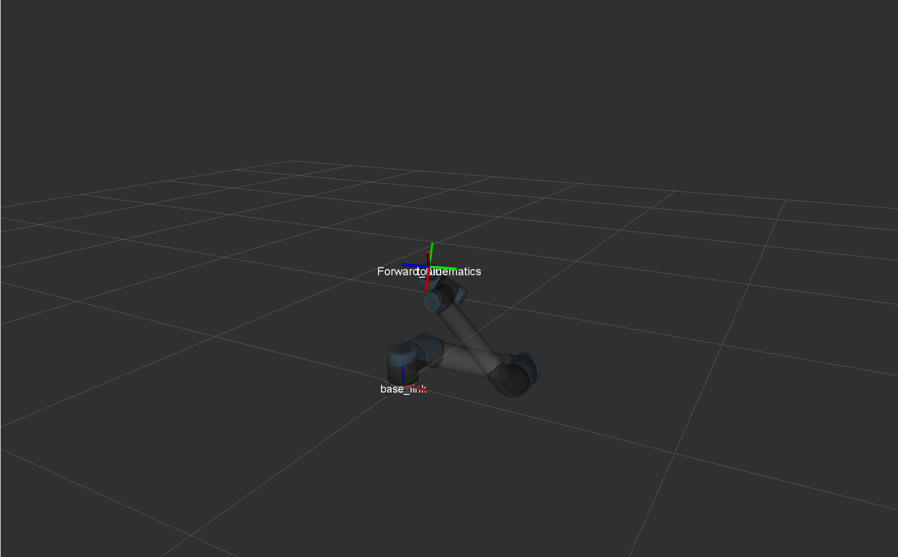

**Transform 2**

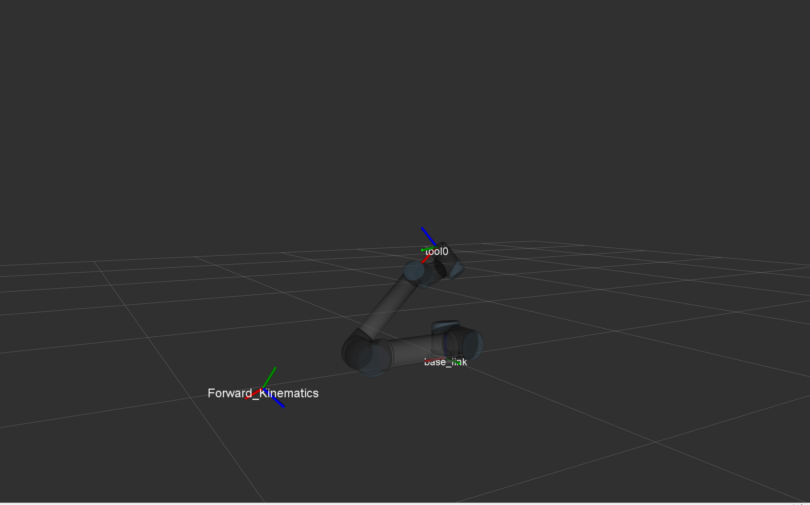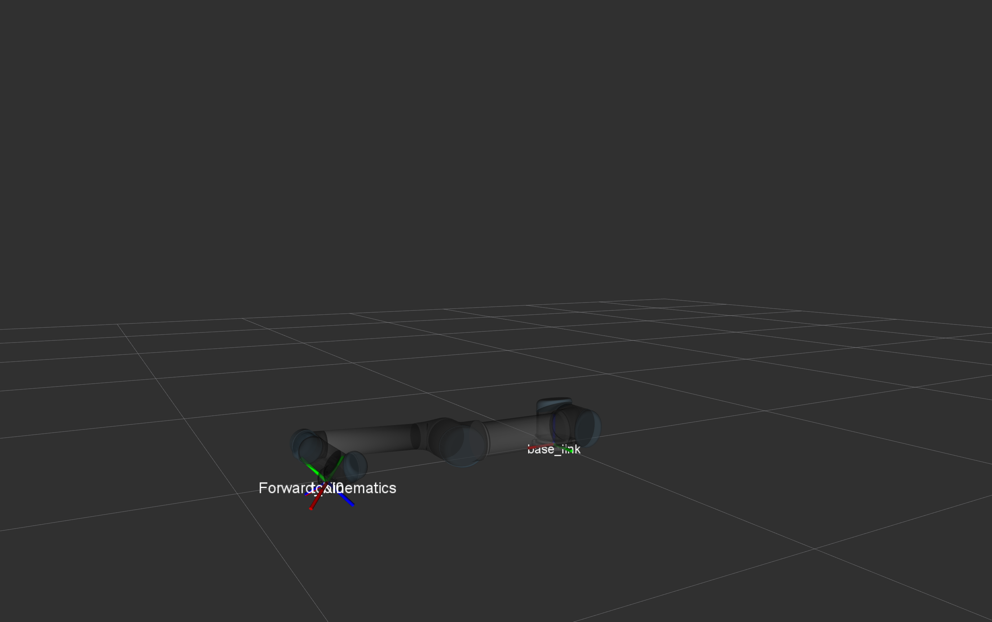

**Transform 3**

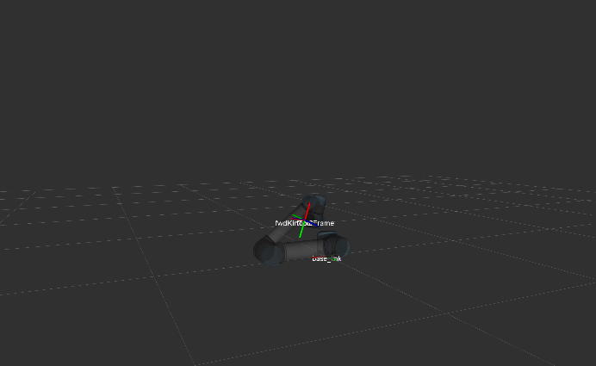

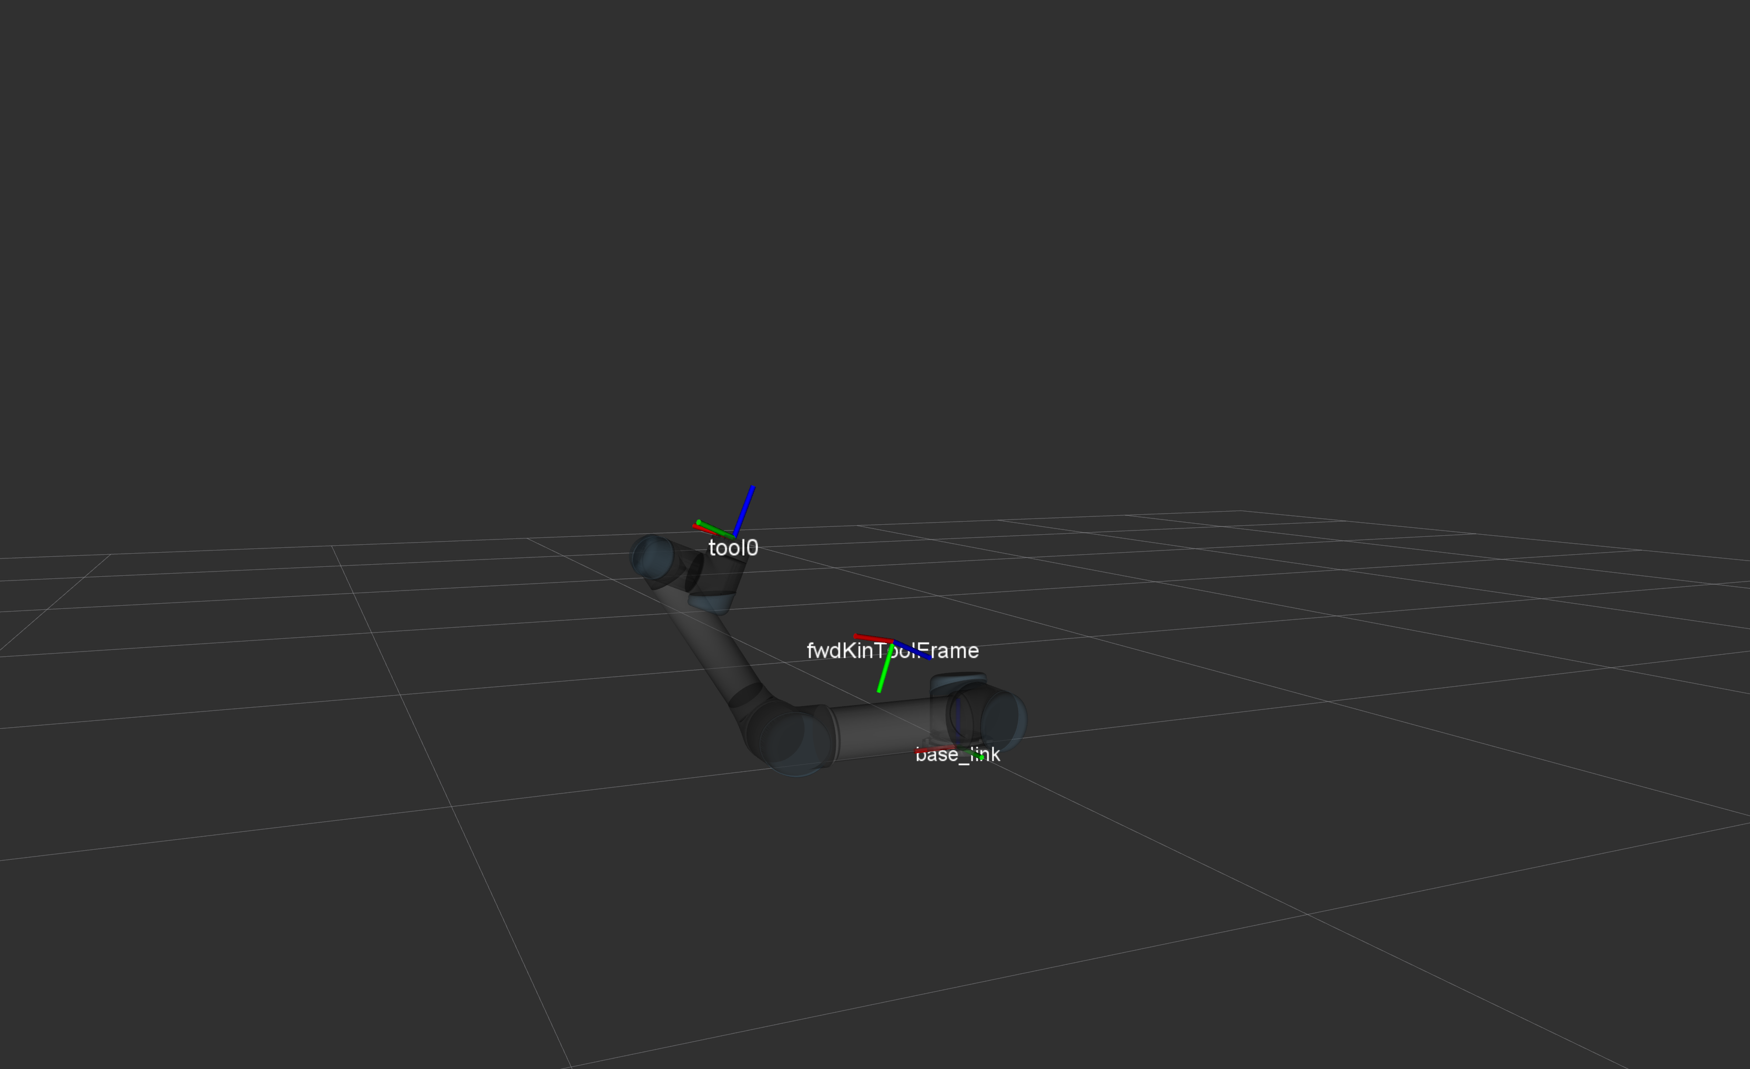

**Transform 4**



